Growth requires leadership skills:
Expansion of the WFL Millturn Technologies management board guarantees reliability

WFL Millturn Technologies is sending a strong signal by expanding its management board which now includes two experienced executives from WFL’s own ranks: previous Commercial Manager Stefan Hackl and Head of Order Management Franz Schön. WFL’s customers value the quick and unbureaucratic offering and implementation of sophisticated technical solutions as well as the company’s internal cohesion. The expansion of the management board allows for these quick decisions at every level.

As CFO, Stefan Hackl will continue to be responsible for finance, HR and IT. In his new role as COO, Franz Schön will concentrate on order management and production. CEO Norbert Jungreithmayr will continue to act as Chairman of the Management Board and CTO Günther Mayr will be responsible for all agendas relating to technology and sales.

"Constantly changing markets, technologies and customer requirements keep us busy every day. Thanks to our customer-oriented strategy we can not only take account of market dynamics and align our products and services accordingly, but also seize opportunities and protect ourselves from risks. We want to continue positioning WFL in such a way that long-term sustainability can be practiced, and thus further growth can be ensured. The decision to expand our management board is a strong sign of our endeavours to further expand our technological leadership," outlines CEO Norbert Jungreithmayr.

“Stefan Hackl and Franz Schön have contributed significantly to the company’s success so far. Their new positions in the company underline these achievements and ensure that we as a team lead the company successfully into the future,” emphasizes CTO Günther Mayr.

Since WFL Millturn Technologies was founded 30 years ago, the company has achieved many milestones and goals, primarily thanks to the expertise and commitment of its employees. WFL Millturn Technologies strives to secure further growth and expand its technological leadership. The entrepreneurial focus of WFL’s thoughts and actions is entirely on solving the respective production tasks and thus achieving customer satisfaction.

CFO Stefan Hackl has been with the company since 2019. "I am delighted to be able to contribute to WFL’s success story as CFO. For me, this is both a privilege and an incentive. I enjoy helping to successfully shape the corporate strategy, optimising processes, and using the right levers with forward-looking, well-founded figures, as well as working with a great, international team. This is how we prepare WFL for the future together," says the new Managing Director Stefan Hackl.

"I have already been working for WFL for more than 30 years and I am very pleased to take on my new role as Managing Director as this means I can help shaping and supporting our common goals even more actively in the future. Regarding Order Management and Manufacturing Solutions, it is our responsibility to support our customers throughout the entire process chain, from receipt of order to the end of the machines' life, and to fulfil their requirements in the best possible way by acting quickly. I am highly motivated to implement and advance these tasks together with all my colleagues," says the new COO Franz Schön.

unten Contact:
WFL Millturn Technologies GmbH & Co. KG
Wahringerstraße 36, A-4030 Linz
Phone: +43 732-6913-0
www.wfl.at

Photos:
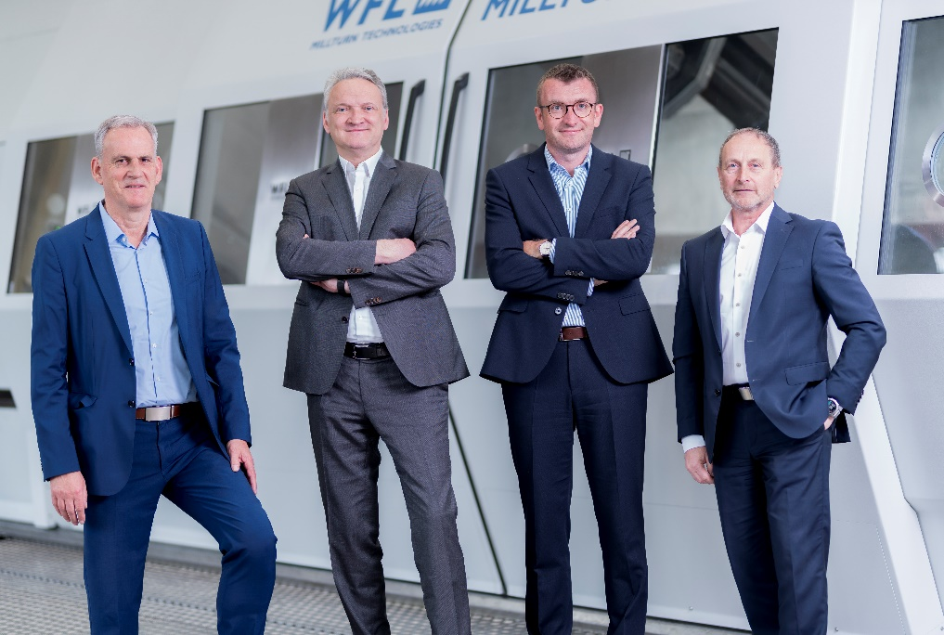
01: The WFL Management Board: (v.l.) CTO Günther Mayr, CEO Norbert Jungreithmayr, CFO Stefan Hackl and COO Franz Schön.

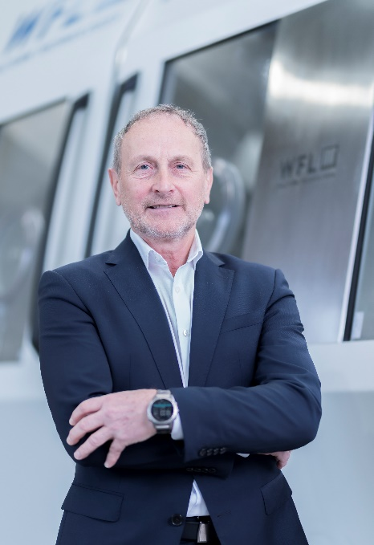 | 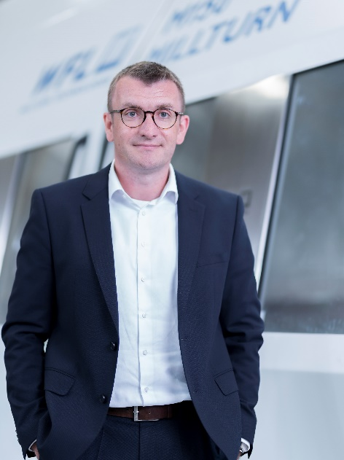
02: Franz Schön, COO at WFL MILLTURN Technologies and new member of the WFL Management Board | 03: Stefan Hackl, CFO at WFL MILLTURN Technologies and new member of the WFL Management Board

